114學年下學期二年級英文暑假作業
任務一 | 英文字母學習  Sing the Alphabet Song  Do the Alphabet Dance  Learn more about ABCs  Alphabet Vocabulary Learning |       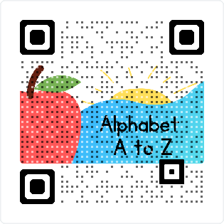
任務二 | 我們身邊的蝴蝶與其他昆蟲  Sing “Fly Fly the Butterfly”  Complete the lyrics  Listen to the song and  review “Insects” | 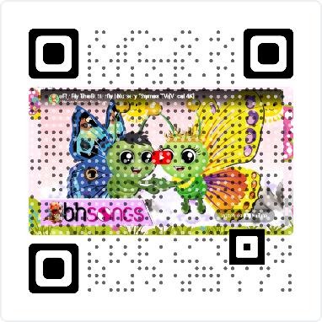  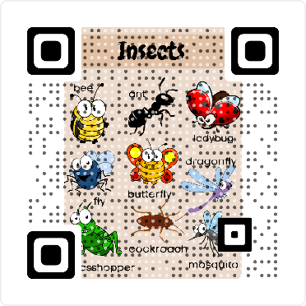
任務三 | 我們來複習一下  Let’s talk about Colors  Play the Color Gameshow Quiz | 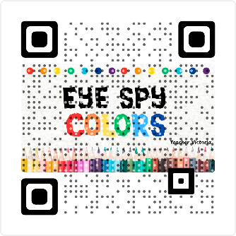  
任務四 | 我們來用形容詞練習英文吧  - Colors and Insects Worksheet  - Colors and Animals  - Colors and Animals Match up | 